COMPREHENSIVE PLAN PILOT GRANT
PROPOSAL FORM
Please complete all sections and attach any citations, letters of support or appendices on separate pages and upload all materials at www.bcidahofoundation.org/comp-2021/
Proposals should not exceed 5 pages and should be double spaced.

CITY 2020 CENSUS INFORMATION:
- Population
- Median Household Income
- Housing Units
- Total Households
- Employment Rate
- Percent of Population that is Hispanic or Latino
CITY LEADERSHIP:
- Mayor’s name and term expiration year
- List City Council members and their term expiration years
- City Administer/Planner name
- City motto (if applicable)

CITY COMPREHENSIVE PLAN INFORMATION:
When was your city’s comprehensive plan last reviewed? What changes were made and why?

What is the timeline for your next comprehensive plan update?

Why does your city desire to address health within its comprehensive plan?

List any short-term and long-term outcomes your community hopes to achieve through an amendment to the comprehensive plan with a focus on community health.

Please review the chart below. In your opinion, explain the areas where your city is excelling and where improvements are needed.
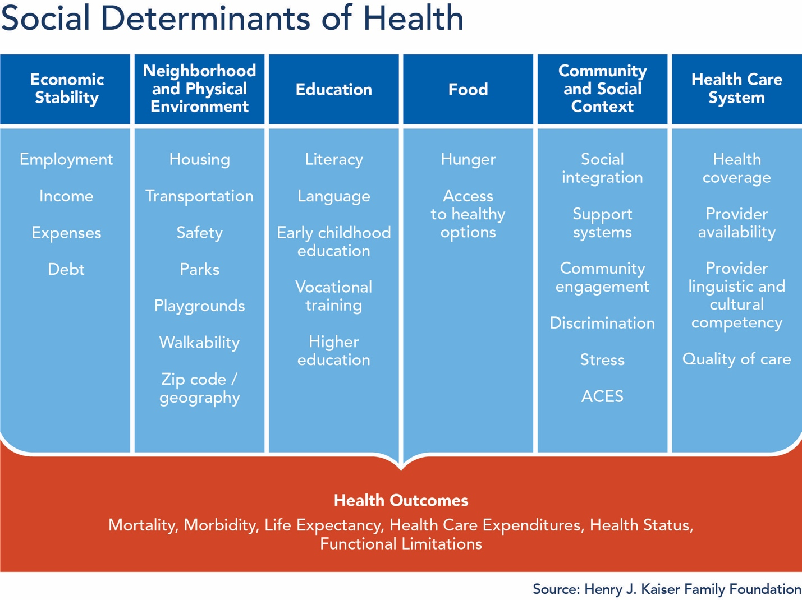

Does your community already have a group or committee meeting to discuss health within the city or community?
- If yes, please explain your group and how it structured and what areas are most discussed?
- If no, what would it take to convene such a group and who would you believe should be included?

A resolution from City Council authorizing acceptance of this grant is required. Can this be obtained by April 2023? If no, please explain why a longer timeline is necessary.

This grant is up to $50,000. Is there additional funding available for other aspects of updating the comprehensive plan?

HELPFUL RESOURCES
Driggs Plan: https://www.driggsidaho.org/comprehensive-plan
APA toolkit : https://www.planning.org/publications/document/9201866/
Change Lab Solutions: https://www.changelabsolutions.org/
Building Healthier Idaho Report: https://www.bcidahofoundation.org/healthy-idaho/

