COMPREHENSIVE PLAN GRANT PROPOSAL FORM
Please complete all sections and attach any citations and letters of support on separate pages. Upload all materials at http://www.bcidahofoundation.org/comp-plan-2022/
Proposals should not exceed 5 pages.

PLEASE PROVIDE 2020 CENSUS INFORMATION:
- Population
- Median Household Income
- Total Households
- Employment Rate
- City demographics

TELL US ABOUT YOUR CITY LEADERSHIP:
- Mayor’s name and term expiration year
- List City Council members and their term expiration years
- City Administer/Planner name
- City motto (if applicable)

PLEASE ANSWER THE FOLLOWING QUESTIONS:
A resolution from City Council authorizing acceptance of this grant is required. Can this be obtained by April 2024? If no, please explain why a longer timeline is necessary.

This grant is up to $30,000. Is there additional funding available for other aspects of updating the comprehensive plan?

When was your city’s comprehensive plan last reviewed? What changes were made and why?

What is the timeline for your next comprehensive plan update?

What do you hope this grant can do for your city?

The purpose of this grant is for cities to take a holistic approach for addressing social determinants of health, not just focusing on parks and recreation. Please review the chart below and explain the areas where your city is excelling and where improvements are needed.
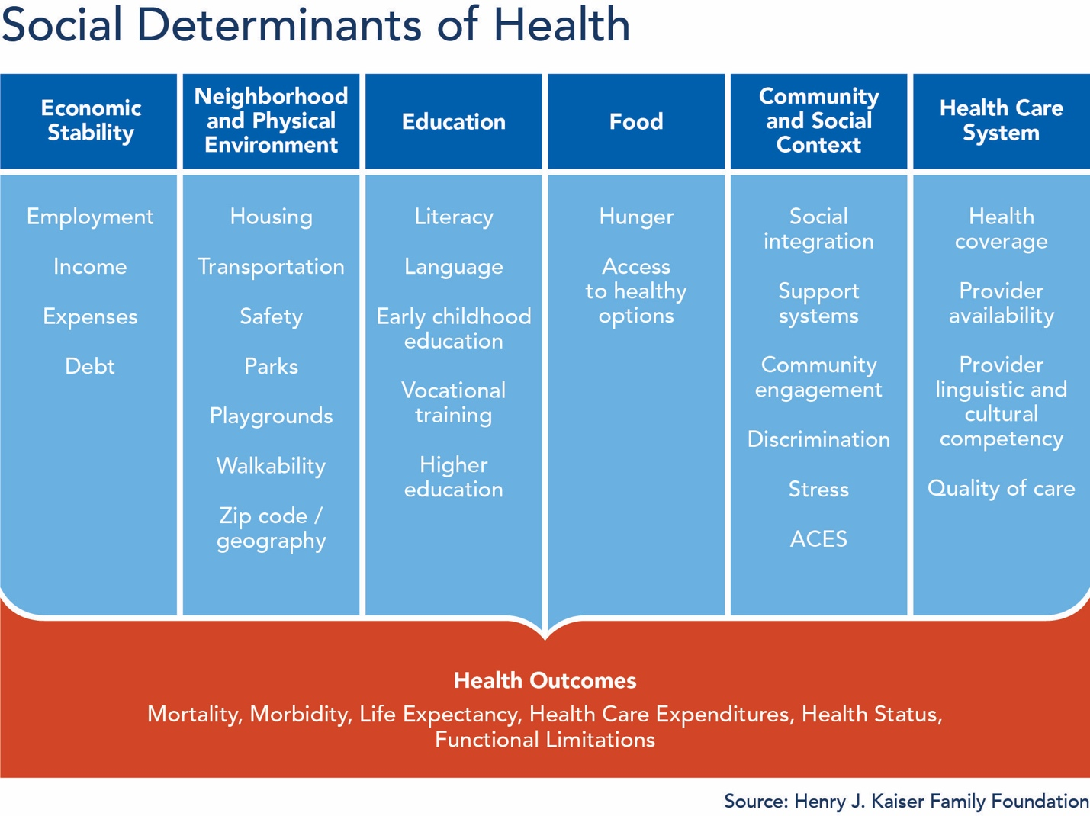

Does your community already have a group or committee meeting to discuss health within the city or community?
- If yes, please explain your group and how it structured and what areas are most discussed?
- If no, what would it take to convene such a group and who would you believe should be included?

How will the city conduct public engagement to include a wide variety of voices in the comprehensive plan update process?

How do you plan to educate the general public about comprehensive plans and community health while getting their input on those topics?

Can you please provide several examples of how the city will measure success if selected as a grant recipient?

HELPFUL RESOURCES
Driggs Plan: https://www.driggsidaho.org/comprehensive-plan
APA toolkit: https://www.planning.org/publications/document/9201866/
Change Lab Solutions: https://www.changelabsolutions.org/
Building Healthier Idaho Report: https://www.bcidahofoundation.org/healthy-idaho/

